Subject: | Art
Title: | Mixing Colours
Grade Level: | 2
Purpose: | - To explore the mixing of colours.
Curricular  Connections: | - Primary colours can be mixed to produce new hues.  - Colour can be lightened to make tints or darkened to make shades. These tints or shades are also referred to as tone or value.
Materials: | - Red, yellow, blue, white and black pastels and white paper  - Jersey that has been pre-coloured by teacher using pastels. The colours on the jersey need to be created by mixing at least 2 colours. An example is provided.  - Blank jersey (one for each student)  - Cotton swabs for blending (Alternatively students could use their fingers.)
Activity: | - Provide students with oil pastels, cotton swabs and paper.  - Give students time for independent exploration of the materials. Ask questions such as: How did you create that colour? What did you do to make that happen? What would happen if …..? Can you create any other colours?  - After ample time for exploration show students the pre-coloured jersey. Inform students that their task is to re-create the jersey using the pastels provided.  - Students complete activity and then have a class discussion on the different hues (mixing primary colours), tints (adding white), and shades (adding black) that students re-created.
Extension: | - Students can further explore mixing colours using paint, food colouring and by layering tissue paper.  - Students design their own mixed-colour jersey.
Assessment: | - During exploration, teacher asks guided questions to assist students with their explorations and discoveries.  - Are students able to mix colours in order to replicate the colours in the pre-coloured jersey?
Jersey Example

This jersey requires students to create the colours orange, pink, green, purple, brown and dark blue.
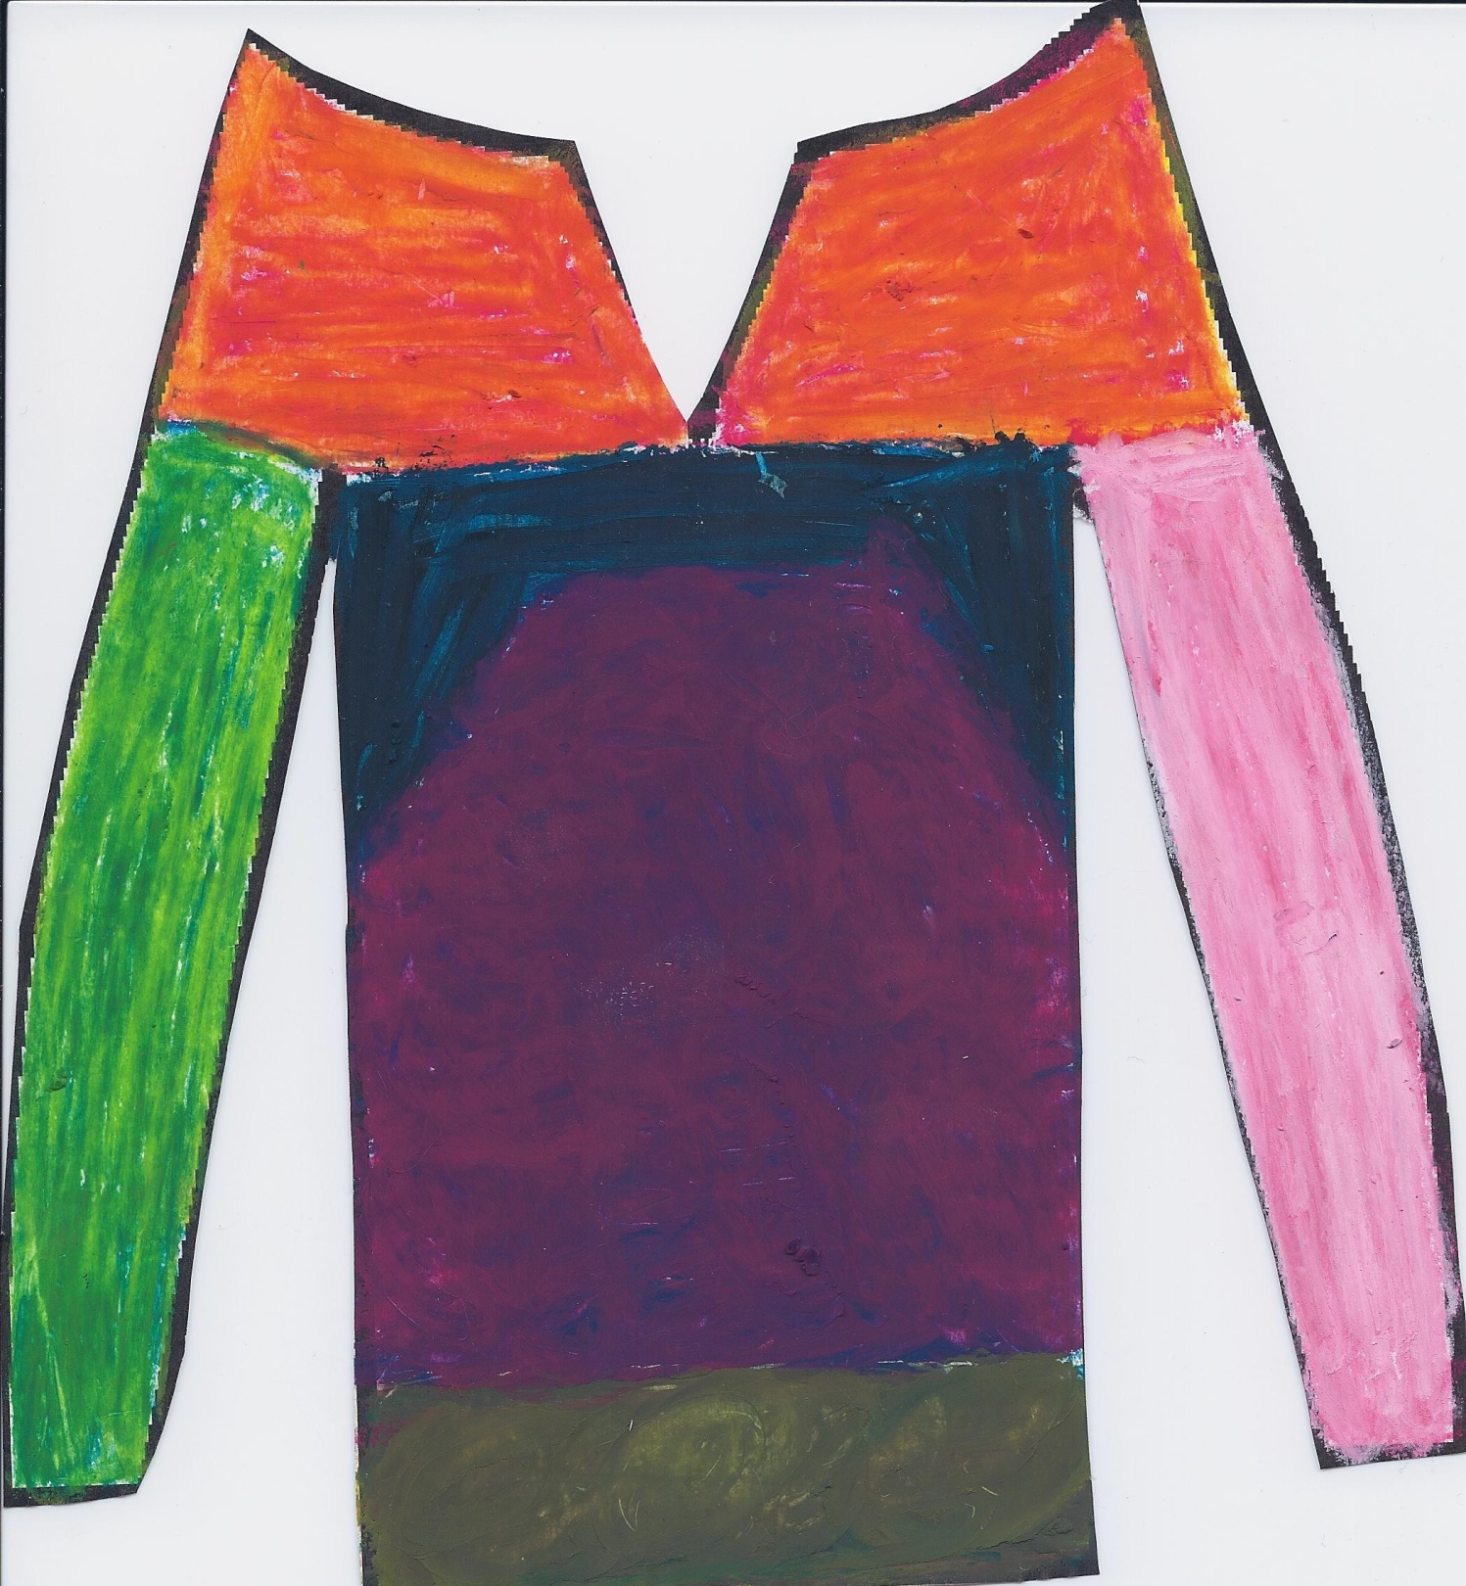
Blank Jersey
