|  |  |
| --- | --- |
| **Title:** | Hockey Store |
| **Grade Level:** | 1 |
| **Purpose:** | * Students use a repertoire of math strategies to solve addition problems. |
| **Curricular**  **Connections:** | * Demonstrate an understanding of addition of numbers with answers to 20 and their corresponding subtraction facts, concretely, pictorially and symbolically, by: * using familiar mathematical language to describe additive and subtractive actions * creating and solving problems in context that involve addition and subtraction * modeling addition and subtraction, using a variety of concrete and visual representations, and recording the process symbolically. |
| **Materials:** | * Short hockey clip or book that shows various hockey equipment. (teacher choice) * Hockey equipment poster * Construction paper (9x12) –one per pair of students * Glue sticks * **“What will you buy?”** recording sheet-at least one per student (attached) * Variety of math manipulatives (e.g. counters, cube links, ten frames, two part mats, number lines, hundred charts) * Blank paper (for extension activity) |
| **Activity:** | 1. Ask students, “Who has watched a hockey game?” Have students discuss experiences with a partner, and then have pairs share with class. 2. Students watch a short hockey video and/or look at a book about hockey (teacher choice). During the video or reading of the book students find answers to the question: **“What equipment do hockey players need?”** 3. As a class generate a list of hockey equipment. Record. 4. Display hockey equipment poster and compare it to the class list. Amend class list if necessary. 5. Model to students how to create a price list.   **Example: Dot’s Sporting Goods**  Hockey puck $2  Hockey Stick $3  Helmet $5  Mouth guard $1  Skates $8   1. Divide students into pairs. Each pair comes up with a name for their store. Next, students create a price list for various pieces of hockey equipment. Remind students to:  * look at the equipment list if needed * keep the prices of the items at their store in the 1-10 dollar range  1. Students paste their price lists onto colored construction paper and post around the classroom. 2. Now students pretend to be customers. Their task is to go to two stores (at least) and decide what to purchase at each store. 3. Model for students how to complete **‘What are you going to** **buy?’** recording sheet. Emphasize that they need to purchase two things from each store, and solve how many dollars they need to purchase those items. 4. Students complete activity. 5. Gather students together and have them share in groups, what items they bought, how much each item was, and how they figured out their answer. |
|  | 1. Students complete activity again using blank paper. This time they purchase more than two items at a time. |
| **Assessment:** | 1. Teacher circulates around the room while students are working, checking for understanding and providing extra support where needed. 2. Students complete the “Review’ sheet”. 3. Interview students one on one and have them explain how they got their answers. |

**Diagram of Hockey Equipment**

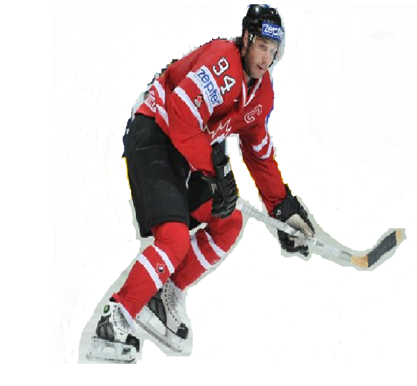

shoulder pads

mouth guard

elbow pads

jersey

shin pads

skates

pants

puck

visor

helmet

gloves

stick

**What are you going to buy?**

Store Name:

|  |  |
| --- | --- |
| Name of Item:  Price: $ | Name of Item:  Price: $ |
| How many dollars do you need? Use pictures, numbers or words to show your thinking. | |

Store Name:

|  |  |
| --- | --- |
| Name of Item:  Price: $ | Name of Item:  Price: $ |
| How many dollars do you need? Use pictures, numbers or words to show your thinking. | |

Name:

**Review**

Use pictures, numbers or words to show your thinking.

Puckster needs some new hockey equipment. Solve the problems below

to help him figure out how many dollars ($) he will require to purchase each set of items.





and

$

helmet

$ 7

elbow pads

$5

1. [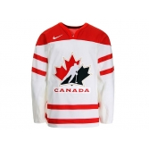](https://shop.hockeycanada.ca/detail/96)

C:\Users\Lynn\AppData\Local\Microsoft\Windows\Temporary Internet Files\Content.IE5\YEPKLWCH\MC900292498[1].wmf

and

skates

$9

jersey

$9

$

C:\Users\Lynn\AppData\Local\Microsoft\Windows\Temporary Internet Files\Content.IE5\NE4XNHY8\MC900229987[1].wmf

and

$

puck

$2

gloves

$8