Subject: | Math
Title: | Extending Patterns
Grade Level: | 2
Purpose: | To be able to identify and extend patterns.
Curricular  Connections: | - Demonstrate an understanding of repeating patterns (three to five elements) by describing and extending patterns using manipulatives, diagrams, sounds and actions.
Materials: | - Pre-laminated set of pattern strips and Puckster characters (make enough copies so class can work in pairs)  - Dry erase markers/dry erase crayons and cleaning cloth  - Chartpaper/board and marker
Activity: | - Review what a pattern is.  - Draw a pattern on the board. Add some blank lines at the end. Ask: what part of this pattern repeats? Circle the repeating part. Explain that the part of a pattern that repeats is called the ‘core’ of the pattern. Have students say pattern. Ask: what comes next? Draw correct response on the lines. Ask: how do you know? Explain, when you solve what needs to come next and add it to a pattern you are extending a pattern.  - Model a sound pattern. Ask students: What is the core of this pattern? What comes next?  - Repeat step 3, this time with an action pattern.  - Give each pair of students a set of pattern strips, Puckster characters, and a dry erase marker. Tell students they need to circle the core of each pattern and extend each pattern by solving which character(s) come next.  - Gather students and have them share their experiences.
Extension: | - Students create their own patterns using manipulatives . They circle the core of, and extend, a classmate’s pattern.
Assessment: | - Teacher circulates during activity, providing extra support where needed.  - Performance task: Teacher creates a pattern using manipulatives. Students tell teacher what the core is, then extends the pattern.

Extending Patterns
What character comes next?

 | 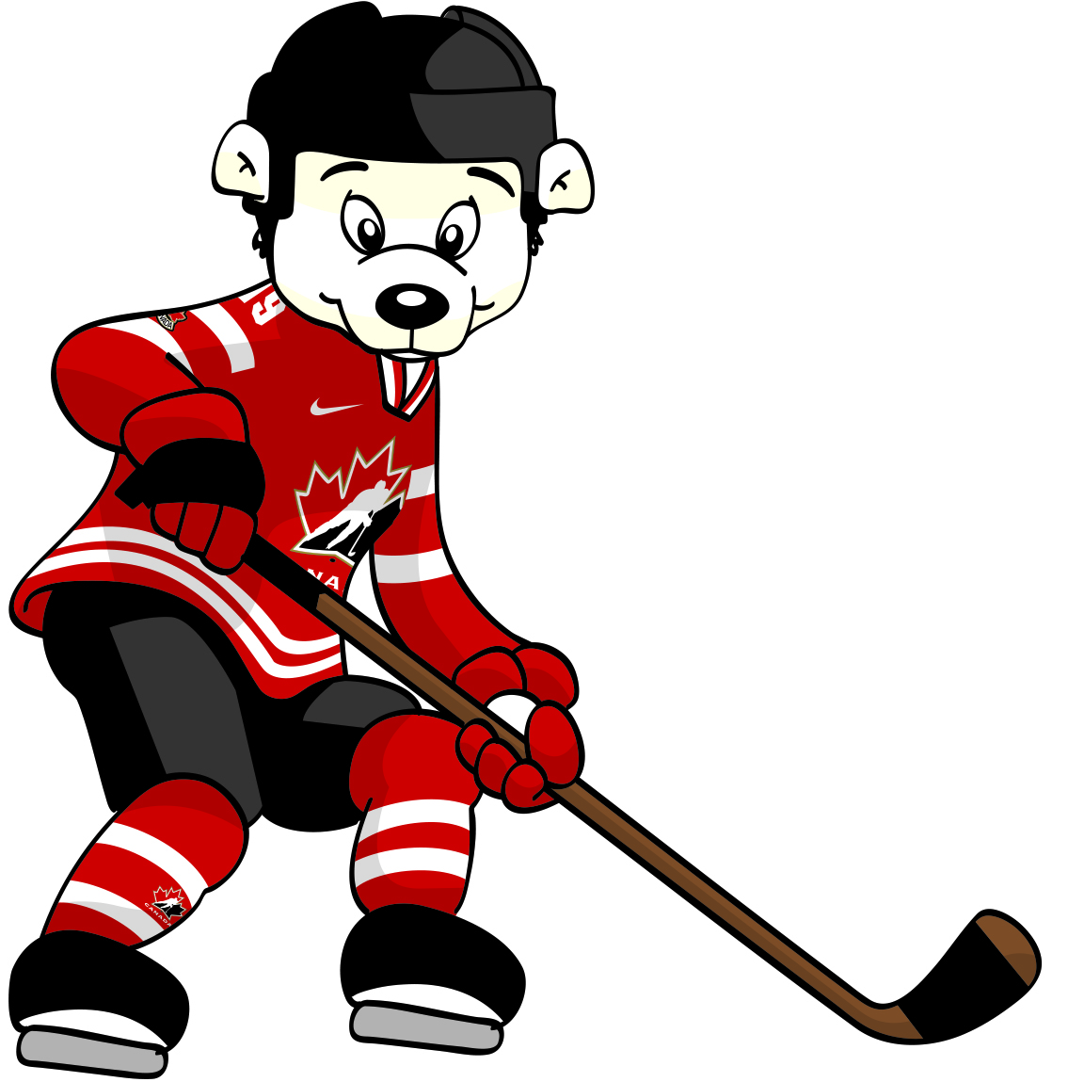 | 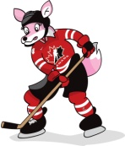

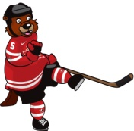 | 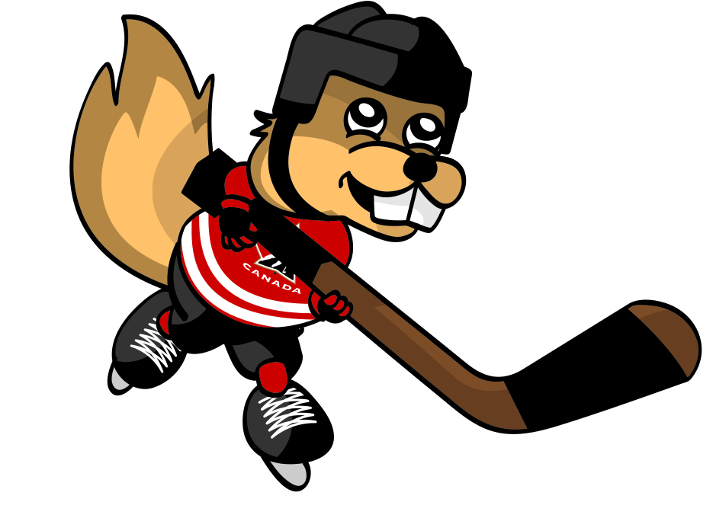

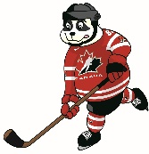 |  | 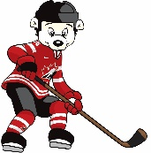 | 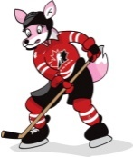

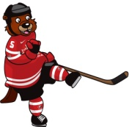
Puckster Characters

