|  |  |
| --- | --- |
| **Subject:** | Mathematics |
| **Title:** | Hockey Store |
| **Grade Level:** | 2 |
| **Purpose:** | * Students will use a repertoire of math strategies to solve addition problems. |
| **Curricular**  **Connections:** | * Demonstrate an understanding of addition (limited to 1- and 2-digit numerals) with answers to 100 and the corresponding subtraction by: * using personal strategies for adding and subtracting with and without the support of manipulatives * creating and solving problems that involve addition and subtraction * using the commutative property of addition (the order in which numbers are added does not affect the sum) * using the associative property of addition (grouping a set of numbers in different ways does not affect the sum) * explaining that the order in which numbers are subtracted may affect the difference. |
| **Materials:** | * Short hockey clip or book that shows various hockey equipment. (teacher choice) * Letter sized poster of a diagram of all the hockey equipment a hockey player wears. * Construction paper (9x12) –one per pair of students * Glue sticks * ‘What will you buy?’ recording sheet-at least one per student (attached) * Variety of math manipulatives (e.g. counters, cube links, ten frames, two part mats, number lines, hundred charts, coins, base ten blocks) * Blank paper (for extension activity) |
| **Activity:** | 1. Ask students, “Who has watched a hockey game?” Have students discuss experiences with a partner, and then have pairs share with class. 2. Inform students that they are going to watch a short hockey video and/or look at a book about hockey (teacher choice). Explain that their job during the video or book is to answer the question, “What equipment do hockey players need?” 3. As a class generate a list of hockey equipment. Record responses. 4. Display hockey equipment poster and compare it to the class list. Amend class list if necessary. 5. Model to students how to create a price list.   Example:  **Dot’s Sporting Goods**  Visor $47  Hockey Stick $33  Helmet $39  Mouth guard $11  Skates $44   1. Divide students into pairs. Have each pair come up with a name for their store. Next, have them create a price list for various pieces of hockey equipment. Remind students to look at the class list if needed. *Tell students they need to keep the prices of the items at their store in the 10-50 dollar range.* 2. Have students paste their price lists onto colored construction paper and post around the classroom. 3. Explain to students that they are now going to pretend to be customers. Their task is to go to two stores (at least) and decide what they want to purchase at each store. 4. Model for students how to complete the ‘What are you going to buy?’ recording sheet. Emphasize that they need to purchase two things from each store and solve how many dollars they will need to purchase those items. 5. Have students complete activity. 6. Gather students together and have them share in groups; what items they bought, how much each item was, and how they figured out their answer. |
| **Extension:** | 1. Students can complete the activity again using blank paper. This time purchasing more than two items at a time. 2. Students can be given a certain amount of money to spend at each store, when they are purchasing their two items. They have to ensure that they don’t spend more money than what they have. |
| **Assessment:** | 1. Teacher circulates around the room while students are working, checking for understanding and providing extra support where needed. 2. Students complete the “Review’ sheet”. 3. Interview students one on one and have them explain how they got their answers. |

**Diagram of Hockey Equipment**

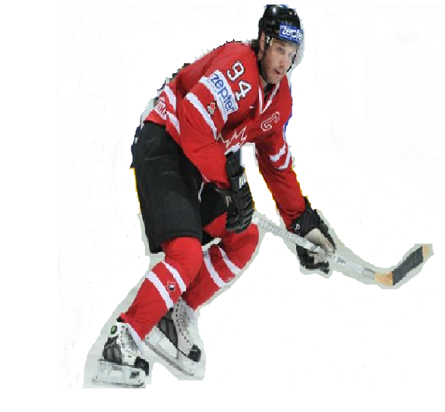

shoulder pads

mouth guard

elbow pads

jersey

shin pads

skates

pants

puck

visor

helmet

gloves

stick

Name:**_______________________**

**What are you going to buy?**

Store Name:

|  |  |
| --- | --- |
| Name of Item:  Price: $ | Name of Item:  Price: $ |
| How many dollars do you need? Use pictures, numbers or words to show your thinking. | |

Store Name:

|  |  |
| --- | --- |
| Name of Item:  Price: $ | Name of Item:  Price: $ |
| How many dollars do you need? Use pictures, numbers or words to show your thinking. | |

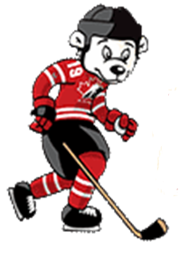Name:

**Review**

Use pictures, numbers or words to show your thinking.

Puckster needs some new hockey equipment. Solve the problems below

to help him figure out how many dollars ($) he will require to purchase each set of items.





and

$

helmet

$ 38

elbow pads

$27

1. [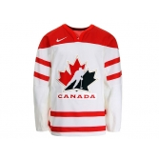](https://shop.hockeycanada.ca/detail/96)

C:\Users\Lynn\AppData\Local\Microsoft\Windows\Temporary Internet Files\Content.IE5\YEPKLWCH\MC900292498[1].wmf

and

skates

$44

jersey

$49

$

C:\Users\Lynn\AppData\Local\Microsoft\Windows\Temporary Internet Files\Content.IE5\NE4XNHY8\MC900229987[1].wmf

and

$

stick

$33

gloves

$35