|  |  |
| --- | --- |
| **Subject:** | Mathematics |
| **Title:** | Hockey Store |
| **Grade Level:** | 3 |
| **Purpose:** | * Students will use a repertoire of math strategies to solve addition problems. |
| **Curricular**  **Connections:** | * Demonstrate an understanding of addition and subtraction of numbers with answers to 1000 (limited to 1-, 2- and 3-digit numerals), concretely, pictorially and symbolically, by: * using personal strategies for adding and subtracting with and without the support of manipulatives * creating and solving problems in context that involve addition and subtraction of numbers. |
| **Materials:** | * Short hockey clip or book that shows various hockey equipment. (teacher choice) * Hockey equipment poster * Construction paper (9x12) –one per pair of students * Glue sticks * ‘What will you buy?’ recording sheet-at least one per student (attached) * Math manipulatives (e.g. place value charts, fake money, base ten blocks) * I-pads/computers * Blank paper (for extension activity) |
| **Activity:** | 1. Ask students, “Who has watched a hockey game?” Have students discuss experiences with a partner, and then have pairs share with class. 2. Inform students that they are going to watch a short hockey video and/or look at a book about hockey (teacher choice). Explain that their job during the video or book is to answer the question, “What equipment do hockey players need?” 3. As a class generate a list of hockey equipment. Record responses. 4. Display hockey equipment poster and compare it to the class list. Amend class list if necessary. 5. Model to students how to create a price list.   Example:  **Dot’s Sporting Goods**    Visor $57  Puck $4  Hockey Stick $185  Helmet $39  Mouth guard $11  Skates $294   1. Divide students into pairs. Have each pair come up with a name for their store. 2. Have students use the I-Pads/computers to research the prices of various pieces of hockey equipment and create a price list for all the various equipment. Inform students that they need to use a variety of dollar values (1, 2, and 3 digit numerals) and that they need to drop the decimal (cents) and just use whole dollars for their prices. 3. Have students paste their price lists onto colored construction paper and post around the classroom. 4. Explain to students that they are now going to pretend to be customers. Their task is to go to two stores (at least) and decide what they want to purchase at each store. 5. Model for students how to complete the ‘What are you going to buy?’ recording sheet. Emphasize that they need to choose four things from each store and solve how much money they will need to purchase those items. Add the requirement that they need to use a mixture of 1,2, and 3 digit numerals when choosing what they want to buy. 6. Have students complete activity. 7. Gather students together and have them share in groups; what items they bought, how much each item was, and how they figured out their answer. |
| **Extension:** | 1. Students can complete the activity again using blank paper. This time purchasing more than four items at a time. 2. Students can be given a certain amount of money to spend at each store, when they are purchasing their items. They have to ensure that they don’t spend more money than what they have. |
| **Assessment:** | 1. Teacher circulates around the room while students are working, checking for understanding and providing extra support where needed. 2. Students complete the “Review’ sheet”. |

**Diagram of Hockey Equipment**

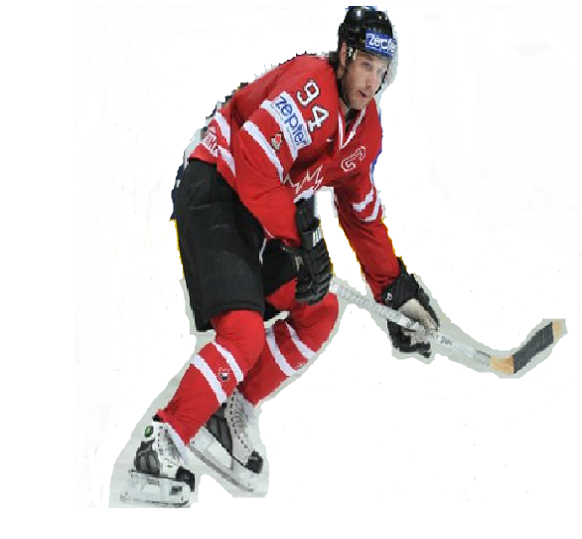

shoulder pads

mouth guard

elbow pads

jersey

shin pads

skates

pants

puck

visor

helmet

gloves

stick

Name:

**What are you going to buy?**

Store Name:

What are you going to buy?

|  |  |  |
| --- | --- | --- |
|  | **Equipment** | **Price** |
| 1. |  | $ |
| 2. |  | $ |
| 3. |  | $ |
| 4. |  | $ |

How much money do you need to purchase these items? Show your work.

Store Name:

What are you going to buy?

|  |  |  |
| --- | --- | --- |
|  | **Equipment** | **Price** |
| 1. |  | $ |
| 2. |  | $ |
| 3. |  | $ |
| 4. |  | $ |

How much money do you need to purchase these items? Show your work.

Name:

**Review**

Use the pricelist to solve the word problems. Remember to show your work.

**Dot’s Sporting Goods**

|  |  |  |
| --- | --- | --- |
| Visor $119 | Stick $185 | Skates $294 |
| Puck $4 | Helmet $39 | Shin pads $67 |
| Elbow pads $43 | Mouth guard $11 | Gloves $88 |

* 1. Hayley needs to buy a pair of skates, a hockey stick and a puck. How much money does she need?
  2. Jerome needs to buy a visor, a helmet and a mouth guard. How much money does he need?
  3. Cassie and Wayne ***both*** need to purchase a pair of gloves and shin pads. How much money do they need?