Subject: | Math
Title: | Hockey Puzzle – Percentages
Grade Level: | 6
Purpose: | Students match the fraction and decimal to the related percentage to discover the name of the Hockey Canada player.
Curricular  Connections: | - Demonstrate an understanding of percent (limited to whole numbers), concretely, pictorially and symbolically.
Materials: | - Worksheet – “Hockey Puzzle - Percentages”
Activity: | - Review fractions, decimals, and percentages with the class.  - Quiz students with different fractions, decimals, and percentages. Have them provide the equivalencies.  - Distribute worksheet.  - Read directions to students and check for understanding.  - Students complete worksheet by finding the percentage that relates to the fraction, decimal or image. They fill in the capital letters to spell the name of a hockey player.
Extension: | Students create their own percentage math puzzle with a classmate’s name as the answer. Choose a friend to solve the equations.
Assessment: | Student is able to:  - Understand the relationship between fractions, decimals and percentages.  - Accurately identify percentage shown concretely, pictorially and symbolically.

HOCKEY PUZZLE - Percentages
Name:__________________

Use the letter of the related percentage to spell the name of the player.
 | R. 0.94 | O. $\frac{35}{100}$ | I. 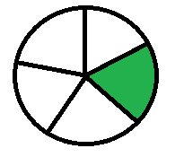 | C. 0.05
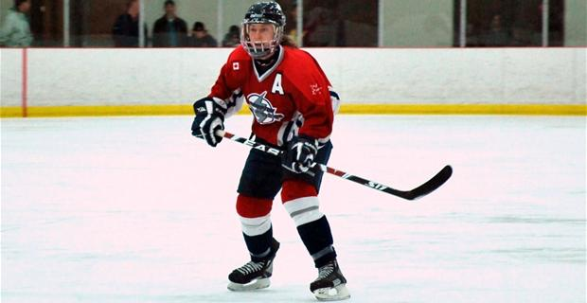 | E. $\frac{17}{100}$ | S. 0.24 | E. $\frac{3}{4}$ | Y. 0.58
 | L. 0.26 | U. $\frac{42}{100}$ | E. 0.03 | L.
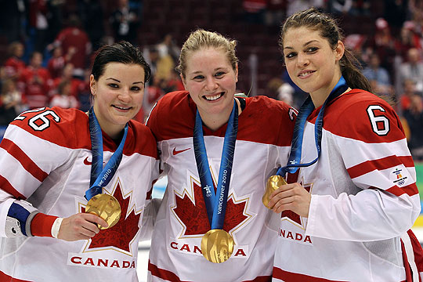 | E. 0.7 | T. 0.15 | N. $\frac{4}{10}$ | A. 0.67
 | O.  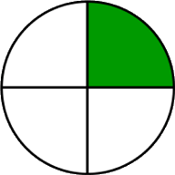 | B. 0.42 | T. 0.81 | L. $\frac{46}{100}$

This hockey hero plays forward for the Canadian national women's ice hockey team. She is a 4-time Olympic Gold Medallist and was the captain of the women’s team in the Sochi 2014 Winter Olympics.

5% 67% 94% 25% 26% 20% 40% 75% 35% 42% 17% 46% 50% 70% 15% 81% 3%

