Subject: | Math
Title: | Number Maze
Grade Level: | K
Purpose: | A fun activity to challenge students’ counting and their ability to trace numbers.
Curricular  Connections: | - Develop number sense.  - Represent and describe numbers to 10
Materials: | - Set of 20 objects.  - Picture of 20 objects.  - Chart paper or blackboard  - Copy of worksheet: Number Maze
Activity: | - Lesson on counting using manipulates or pictures.  - Ask students to count forward 1 – 10 as you point to manipulates or pictures.  - Print numbers on the board or chart paper as students count.  - When all the numbers from 1 – 10 are written down, point to different numbers and ask students to say the number.  - Challenge students with the numbers 11-20.  - Distribute worksheet: Number Maze  - Read directions together. Have students say the numbers and “walk” the path with their finger from 1 – 10.  - Go back to Charlie and start at 1 again. This time continue counting after 10.  - Students work independently to complete worksheet. If the numbers 11-20 are too difficult, complete those together as a class. (teacher-directed)
Extension: | Using the “path” to the ice rink with the numbers from 1-20 clearly visible, identify the number, up to 20, that is:  - one more, two more, one less, two less, than a given number
Assessment: | - Observe students as they trace the numbers. Give assistance if necessary.  - Students: -can count to 10  -can trace the numbers carefully

Number Maze Name

Can you help Charlie the chipmunk get to the ice rink? Draw a path from Charlie to the ice rink by counting from 1 to 20 and tracing the numbers.

 |  | 1 | 2 | 8 | 9
 |  | 7 | 3 | 4 | 5
3 | 5 | 11 | 10 | 9 | 6
14 | 13 | 12 | 6 | 8 | 7
15 | 6 | 19 | 20 | 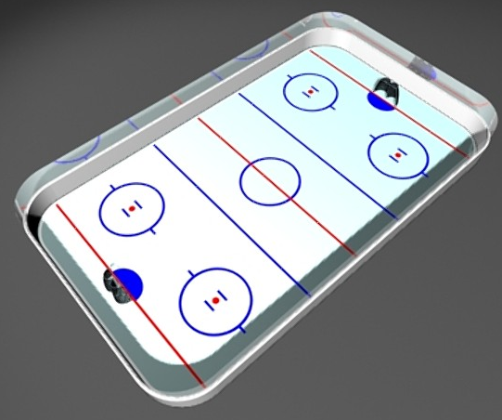
16 | 17 | 18 | 2

