Subject: | Physical Education
Title: | Floorball: An Introduction to Hockey
Grade Level: | 3
Purpose: | - Students are introduced to the sport of Floorball. Floorball is a fun, safe and fast paced form of floor hockey developed in the 1970’s in Europe. The game is played indoors on a gym floor with specialized lightweight sticks and rules that make game play much safer than traditional floor hockey. For more information on Floorball, please visit: http://www.hockeycanada.ca/en-ca/Hockey-Programs/Schools/Floorball/What-is-Floorball.aspx
Curricular  Connections: | - Consistently and confidently perform locomotor skills and combination of skills, by using elements of body and space awareness, effort and relationships to a variety of stimuli to improve personal performance.  - Select, perform and refine more challenging nonlocomotor sequences.  - Select, perform and refine more challenging ways to receive, retain and send an object with control.
Materials: | - Floorball sticks  - Floorball balls  - Goalie masks  - Hockey nets  - Pinnies  - Construction paper (tournament bracket, markers) to record results. *If required.
Activity: | - Activity: Stick Grip and Athletic Stance  Have students stand in a line facing the teacher. Each student must demonstrate proper athletic stance and stick grip. Once students have executed a proper athletic stance and stick grip, have them push the ball along the floor in a rectangle pattern, using the gym floor lines as visual guides. Progress to having students push the ball along the floor, this time weaving over and back across the gym floor line pattern (using as much space as available). While students complete these activities, it is important to remind them to move safely in their space and be aware of their stick at all times.  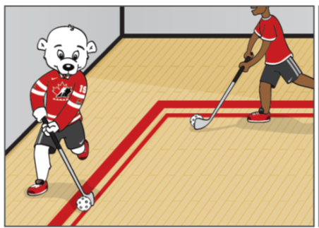  - Activity: Sharks and Minnows  In a confined space (for example, half the gym) each student pushes the ball freely in the identified zone (shark tank). Students are “Minnows” and the teacher is the “Shark”. In a controlled manner the teacher challenges random students to lose the ball. Teacher uses his/her stick in a slow windshield wiper motion to make contact with the student’s ball, being careful not to hit, lift or pin the student’s stick. Once the teacher makes contact with the student’s ball and it goes out of the shark tank, they must chase after their ball. Upon retrieval of ball, student must perform a specified fitness blast (ten jumping jacks, five burpees, etc.) in order to enter back into the shark tank.  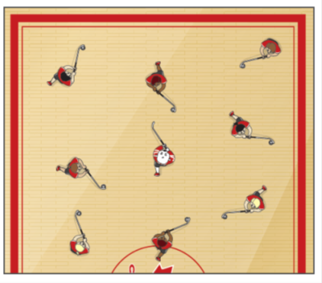  - Activity: Piston Passing  Split the class into groups of five. Give each group a designated space in the gym. The group of five then splits into two single file lines, facing each other, three stick lengths apart. Student 1 begins with the ball on their stick, takes two steps, and passes to the first player in the opposite line (student 2). Student 1 follows their pass to join the end of the opposite line. Student 2 receives the pass, takes two steps and passes to the first student in the opposite line (student 3). Repeat continuously. Students are encouraged to run to the end of the opposite line after releasing the ball.  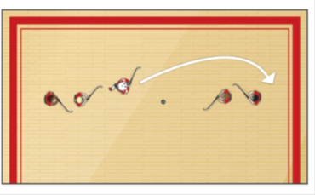  - Activity: Play a Floorball game  Split the class into even teams of five or six players depending on class and gym size. Play five minute full court games.  Brief summary of the rules of Floorball:  • Sticks must remain below waist  • Ball is played below knee level at all times  • No body contact, no blocking/screening of opposing players  • Stick on body contact, or stick on stick contact, is not permitted  • No hitting, lifting or pinning of opponent’s stick.  • Free hits, similar to free kicks in soccer, are given for minor rule infractions  • No off-sides or icing calls  • Game is played with 5 players and 1 goalie per team on the court at one time  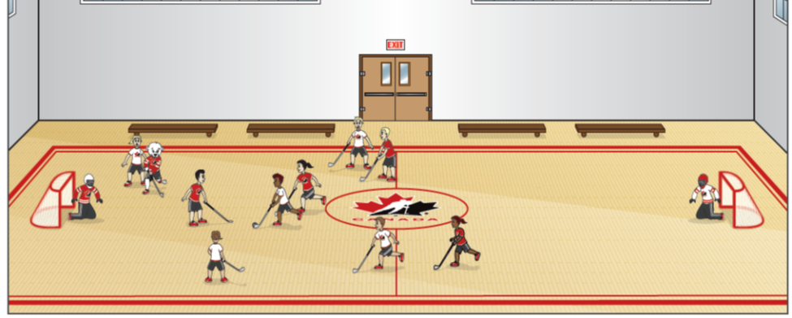
Extension: | - Use tournament format, where scores are recorded. You will need construction paper to create brackets.  - Students create team names.  - Have set positions: centers, wingers, defensemen, and goalies.
Assessment: | - Students are actively participating during drills and game play.  - Check for ability to receive, retain and send the ball.  - Students are demonstrating cooperative and fair play with teammates and opponents.

