Subject: | Science
Title: | Mammal Research - #2
Grade Level: | 3
Purpose: | Students identify different animal “characters” in the Puckster books, and learn about their individual characteristics and life cycles.
Curricular  Connections: | - Describe the appearances and life cycles of some common animals, and identify their adaptations to different environments.
Materials: | - Chart paper for instruction  - Handout  - Animal Books; Access to internet
Activity: | - Talk about the appearance of some common mammals.  - Classify an animal together based on observable characteristics.  - Complete a large graphic organizer on chart paper with the following titles: size/shape, limbs, adaptations, body covering, backbone, and “other” (claws, teeth, etc.)  - Show the life cycle of the animal.  - Have students choose a mammal from the 7 Puckster characters that they would like to research.  - Hand out organizers. Provide opportunities for research.  - Students research the various topics to complete the organizer. Attach a “real” picture on their worksheet.  - Draw simple life cycle on back of worksheet. For example, a deer: 1st fawn, 2nd adolescence, 3rd adult, 4th mother and babies.  - Draw a picture of the animal in the middle of the organizer.
Extension: | - Share information with a classmate, who chose a different mammal or the same one, to compare.  - L.A.: Write a paragraph using the information in your organizer.
Assessment: | - Observe students as they complete organizer.  - Evaluate for understanding: correct information; details.

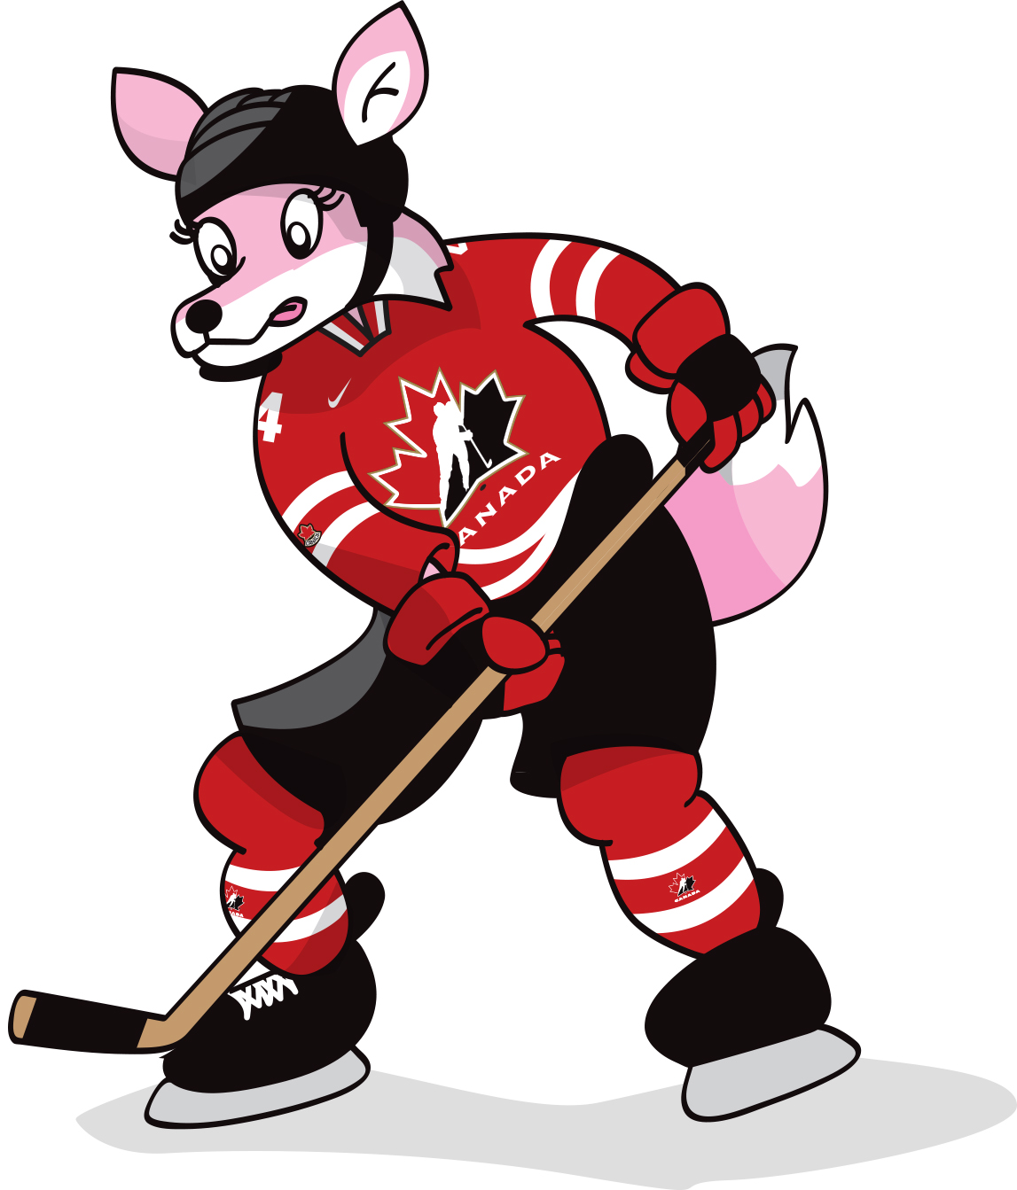
MAMMAL RESEARCH
Name:

Sarah is a fox. In the Puckster books she is a hockey player, but in real life a fox is a mammal. Let’s discover more about foxes using this organizer.

Size:

Shape:
Limbs:

Adaptations:
Body Covering:

Backbone:
Other:
A Fox
MAMMAL RESEARCH
ame:
Name:

Charlie is a chipmunk. In the Puckster Books he is a hockey player, but in real life a
chipmunk is a mammal. Let’s discover more about chipmunks using this organizer.

Ba

Hom
Lim
Size:
Shape:
Limbs:

A Chipmunk
Other:
Body Covering:
Adaptations:
Backbone:

