Subject: | Science
Title: | Flying to the Olympics
Grade Level: | 6
Purpose: | - Students learn the vocabulary used to describe the controls and major components of an aircraft. They use that vocabulary in a “Flying to the Olympics” passage.
Curricular  Connections: | - Apply appropriate vocabulary in referring to control surfaces and major components of an aircraft. This vocabulary should include: wing, fuselage, vertical and horizontal stabilizers, elevators, ailerons and rudder.
Materials: | - “Label the Airplane” handout  - Overhead or Image on SmartBoard to label with class.
Activity: | - Discuss the importance of flight with students, and how it helps people and teams (such as the men’s and women’s Olympic teams) travel to their destination quickly and safely, such as in flying to Sochi, Russia for the 2014 Olympics.  - Review the control surfaces of an airplane - wing, fuselage, vertical and horizontal stabilizers, elevators, ailerons and rudder.  - Distribute “Label the Airplane” handout. In pencil, students fill out the worksheet. Teacher checks for correct labeling.  - Students then proceed to write a creative paragraph (integrating L.A.) entitled, “Flying to the Olympics”, using a minimum of 6 vocabulary terms effectively from the “Label the Airplane” worksheet. For example: As the Olympic Hockey team boarded the plane they saw the pilot entering the cockpit. Shae Weber noticed the flap on the wing moving downward as the plane prepared for takeoff. The jet engines provided a powerful thrust to lift the plane from the ground……….. etc.
Extension: | - On the back of the handout, or on a blank piece of paper, students use their own words to write what the various controls do, and why they are important for safe air travel.
Assessment: | Students submit:  - “Label the Airplane” handout accurately completed.  - “Flying to the Olympics” passage showing understanding of the functions of 6 or more major components of an aircraft.

Label the Airplane

Name: ______________________

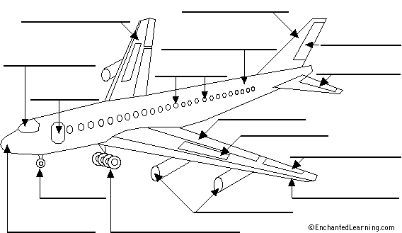

Teacher’s Guide

aileron - the hinged surfaces of the trailing edge of a wing (far from the body of the plane) that move up and down in order to roll the plane from side to side.
cockpit - where the pilots fly the plane, located at the front of the plane.
door - allows people to enter and exit the plane.
elevator - the movable part of the 2 horizontal parts of the tail section that moves up or down to help the plane remain level during flight (the elevator controls pitch) and helps control altitude.
fin - the vertical part of the rear of the tail. The rudder is located on the trailing edge of the fin.
flaps - the hinged, rear edge of a wing (located near the body of the plane); the flaps move downwards during takeoff and landing in order to increase the wing surface and therefore increase lift.
fuselage - the body of the airplane (excluding the wing and tail). Passengers and cargo are carried toward the rear of the fuselage.
jet engines - the part of the aircraft that provides the power for the flight.
landing gear - the retractable wheels fastened to the main part of the body (by struts) - it is used for landing and moving the plane around on the ground.
nose - the forward part of the plane.
nosewheel - the part of the landing gear located under the nose of the plane.
rudder - the vertical part of the tail; it can move left/right to stabilize the airplane during takeoffs and landings in strong wind or in crosswinds (it controls yaw).
slats - the hinged forward edge of a wing; the slats are used during takeoff and landing in order to increase the wing surface and therefore increase lift.
spoiler - small hinged plates located on the top surface of the wings; spoilers are used to slow an aircraft or help it descend by disrupting (spoiling) the flow of air around the wing, increasing the drag.
stabilizer – a fixed wing section that provides stability for the aircraft, so it flies straight
windows - sealed viewing portals, located along the sides of the plane.
wing - the airplane's two wings produce lift as the plane moves through the air. The wings have four moveable controls: ailerons, flaps, slats, and spoilers.

