Subject: | Science (Environmental Awareness)
Title: | Colours
Grade Level: | Kindergarten
Purpose: | - To recognize colours in the environment.
Curricular  Connections: | - Becomes aware of colours in the environment.
Materials: | - Picture of a Hockey Canada jersey  - Pictures of different colored jerseys (not provided)  - Colour Flashcards - one set for each pair of students  - Colour Word Matching Cards - one set for each pair of students  - Colour Assessment page - one per student  - Crayons
Activity: | - Show students picture of the Hockey Canada jersey. Ask them what colours they see.  - Display a variety of pictures of coloured jerseys. Have students share what colours they see on each jersey.  - Hand pairs of students a set of colour flashcards. Have students take turns showing and saying the names of the colours. Students should repeat this activity a few times.  - Provide pairs of students with the colour word matching cards. Have students match the colour words to the correct colour. (They can refer to the colour flashcards, if they get stuck.) Allow students to attempt this several times.
Extension: | - Create a colour book, by having students record objects in the classroom that match the color of a jersey on each page.
Assessment: | - Monitor students during learning activity stage and assist students who are struggling.  - Students complete the ‘Colour Assessment’ page.

Hockey Canada Jersey

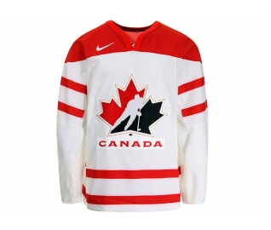

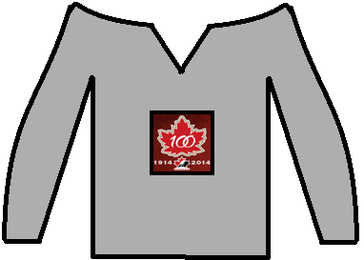
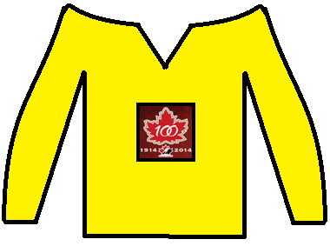
Colour Flashcards
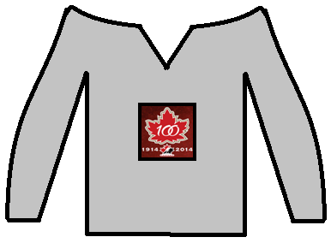  grey | 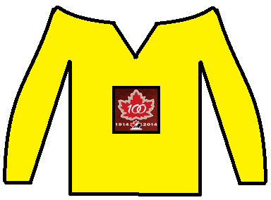  yellow
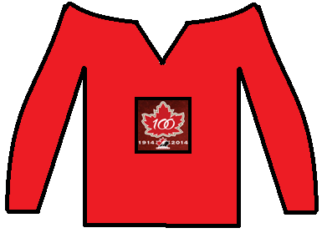  red | 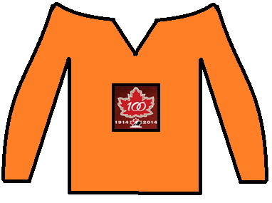  orange
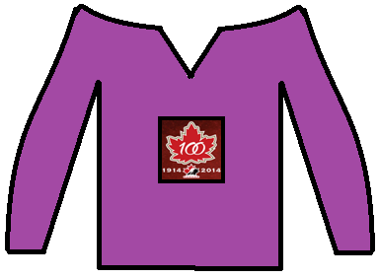  purple | 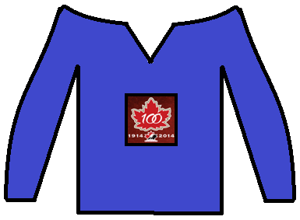  blue
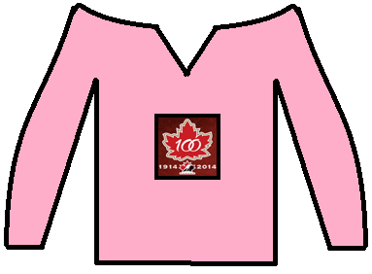  pink | 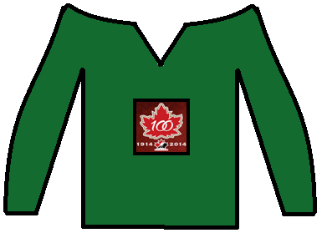  green
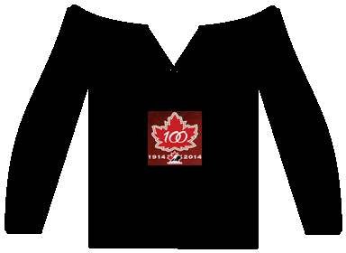  black | 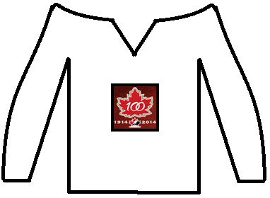  white
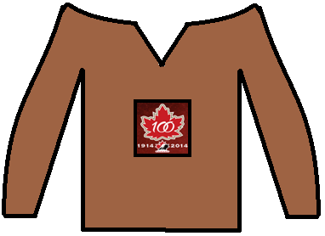
brown

Colour Word Matching
orange | yellow | green
blue | purple | pink
brown | grey | black
white | red

Colour Assessment

Name:
Color the jerseys to match their labels.

purple | brown | black
blue | yellow | red
orange | green | white
grey | pink

