|  |  |
| --- | --- |
| **Subject:** | Science (Environmental Awareness) |
| **Title:** | Using our Senses with Hockey Equipment |
| **Grade Level:** | K |
| **Purpose:** | To explore, investigate and describe various pieces of hockey equipment using the senses. |
| **Curricular**  **Connections:** | * Becomes aware of the five senses and how they are used to explore, investigate, and describe the world. * Shows awareness of similarities and differences in living things, objects, and materials. * Demonstrates awareness of the properties of objects in the environment, by: * Describing some properties * Sorting objects according to common properties; e.g., colour, size, shape, and texture. * Matching objects as being the same or as going together. * Distinguishing between similar objects, based on one or more characteristics. |
| **Materials:** | * Poster: Diagram of Hockey Equipment * Hockey equipment (stick, jersey, skates, helmets, gloves, puck, elbow pads) * Two hula-hoops * Assessment Checklist provided (optional) |
| **Activity:** | 1. Discuss the five senses. 2. Show students the hockey equipment. Ask students if they know what all of these things have in common. 3. Divide students into 7 groups. Give each group one hockey item to explore. Tell students that you want them to use their senses to talk about each item. (e.g. What colour is it? What does it feel like?) 4. After five minutes have groups exchange items. Repeat, until each group has the opportunity to explore all seven items. 5. Call students to the carpet, and show them each object one at a time. Have students share what was said in their groups about each object. Record their responses on a chart. 6. Show students the poster: Diagram of Hockey Equipment. 7. Discuss the various equipment. 8. Have class sit in a circle. Place two hula-hoops in the centre with the hockey equipment. Ask students if they can think of a way to sort these objects into two groups based on something they have in common. (e.g. colour, worn/used, hard/soft). As a class work together to sort the objects in the way that was suggested into the hoops. 9. Repeat this process for other common property suggestions. 10. Have students share two things about what they learned with a partner. |
| **Extension:** | * Provide students with an unlabelled poster; have them copy the names of the various hockey equipment in the appropriate spots. (LA Link) |
| **Assessment:** | * Circulate during group time, and assists students in their discussions by asking guiding questions, and prompting students who require support. * Interview students one-on-one. Have students talk to you about each of the items and then ask them if they can sort the objects into two groups, based on something they have in common. (optional assessment checklist provided) * Are students able to describe some properties of each object? * Are students able to sort the objects into two groups based on common properties? |

**Diagram of Hockey Equipment**

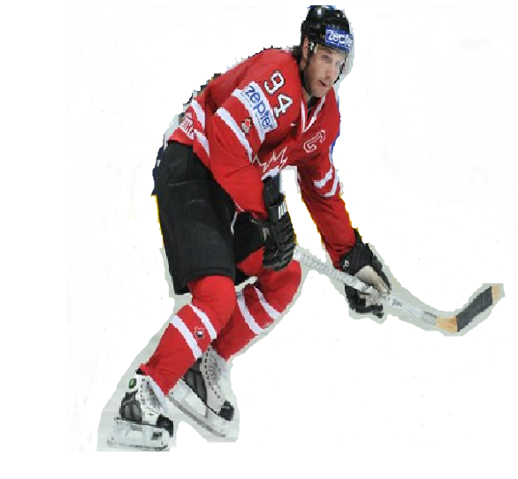

shoulder pads

mouth guard

elbow pads

jersey

shin pads

skates

pants

puck

visor

helmet

gloves

stick

Using our Senses with Hockey Equipment Assessment Checklist

|  |  |  |  |  |  |  |  |  |  |
| --- | --- | --- | --- | --- | --- | --- | --- | --- | --- |
| Student Name | **Describes properties of:** | | | | | | | **Is able to sort objects into two groups based on a common property.** | |
| stick | puck | jersey | helmet | skates | elbow pads | gloves | Yesor No | Property  used |
|  |  |  |  |  |  |  |  |  |  |
|  |  |  |  |  |  |  |  |  |  |
|  |  |  |  |  |  |  |  |  |  |
|  |  |  |  |  |  |  |  |  |  |
|  |  |  |  |  |  |  |  |  |  |
|  |  |  |  |  |  |  |  |  |  |
|  |  |  |  |  |  |  |  |  |  |
|  |  |  |  |  |  |  |  |  |  |
|  |  |  |  |  |  |  |  |  |  |
|  |  |  |  |  |  |  |  |  |  |
|  |  |  |  |  |  |  |  |  |  |
|  |  |  |  |  |  |  |  |  |  |
|  |  |  |  |  |  |  |  |  |  |
|  |  |  |  |  |  |  |  |  |  |
|  |  |  |  |  |  |  |  |  |  |
|  |  |  |  |  |  |  |  |  |  |
|  |  |  |  |  |  |  |  |  |  |
|  |  |  |  |  |  |  |  |  |  |
|  |  |  |  |  |  |  |  |  |  |
|  |  |  |  |  |  |  |  |  |  |
|  |  |  |  |  |  |  |  |  |  |
|  |  |  |  |  |  |  |  |  |  |
|  |  |  |  |  |  |  |  |  |  |
|  |  |  |  |  |  |  |  |  |  |