Subject: | Social Studies
Title: | People in My Hockey Community
Grade Level: | 1
Purpose: | - Students will examine how they belong to their community and value how others, as unique individuals, relate to their hockey community.  - Students identify individuals who make hockey possible in the community.
Curricular  Connections: | - Students will appreciate how belonging to groups and communities enriches an individual’s identity  - Students are to appreciate multiple points of view, languages, cultures and experiences within their groups and communities  - Students demonstrate respect for their individual rights and the rights of others  - Students recognize and respect how the needs of others may be different from their own
Materials: | - chart paper or board to brainstorm vocabulary  - lift-a-flap hand out  - scissors; stapler  - interlined paper for writing sentences as an extension
Activity: | - Introduce hockey theme through story, poem or picture.  - Ask Students:  - who belongs to a community  - who belongs to a team  - what community members are necessary for a team to function and the sport to be played.  - Brainstorm all of the people who make hockey possible in their community. Start with the student as player, and have students think of: parents, siblings, coaches, referees, volunteers, maintenance workers, mascots, etc.  - Remind them to respect every individual in their community  - Distribute lift-a-flap worksheet.  - Students cut along the solid lines, taking care not to cut through the top of each flap. Teacher staples the books along the top.  - Teacher reads sentences aloud and students follow text and repeat sentences.  - Students make real or silly sentences by lifting the flaps in various sequences.
Extension: | - Create a large book and laminate it for the class to use throughout the school year.  - Language Arts: students write real and fantasy sentences on interlined paper using lift-a-flap book.  - Students share their sentences with classmates.  - Students make up sentence and have their partner move their pages to corresponding sentences.
Assessment: | Does the student:  - participate in discussion  - make their booklet independently  - follow the text as it is read  - read sentences fluently  - attend to writing conventions for each written sentence

The player | scores | a goal.
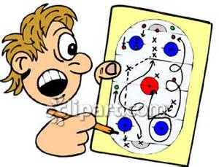  The coach | shows | a play.
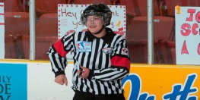  The referee | drops | a puck.
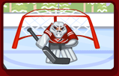  The goalie | stops | a shot.
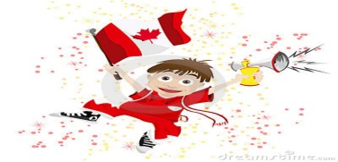  The fan | cheers | a team.

