Subject: | Social Studies
Title: | Hockey Community Helpers
Grade Level: | 2
Purpose: | - To examine another community in Canada and identify the differences and similarities between that community and their own.  - Identify similarities in hockey in both communities, and the individuals who make hockey possible in each community.
Curricular  Connections: | Appreciate the physical and human geography of the communities studied:  - appreciate how a community’s physical geography shapes identity  - appreciate the diversity and vastness of Canada’s land and peoples  - demonstrate care and concern for the environment
Materials: | - Map of Canada  - images of landmarks in the community students will compare  - chart paper or board to brainstorm vocabulary  - chart paper to create Venn diagram for both communities  - lift-a-flap hand out  - scissors; stapler; interlined paper for writing sentences as an extension
Activity: | - Introduce hockey theme through story, poem or picture of community students will study.  - Ask Students about:  - the similarities and differences between their community and the community being studied  - the boys and girls in the compared community; identify what their hobbies, interests, and activities are  - belonging to a team, and what does being on a team entail  - Brainstorm all of the people who make hockey possible in their community. Start with the student as player, and have students think of: parents, siblings, coaches, referees, volunteers, maintenance workers, mascots, etc.  - Determine if the same type of people are essential in both communities to make hockey happen.  - Distribute lift-a-flap worksheet.  - Identify the nouns and verbs in each sentence. Students fill in the missing vowels. Teacher may prompt students.  - Students cut along the solid lines, taking care not to cut through the top of each flap. Teacher staples the books along the top.  - Teacher reads sentences aloud and students follow text and repeat sentences.  - Students make real or silly sentences by lifting the flaps in various sequences.
Extension: | - Create a large book and laminate it for the class to use throughout the school year.  - Language Arts: students write real and fantasy sentences on interlined paper using lift-a-flap book.  - Students share their sentences with classmates.  - Students read a sentence and have their partner move their pages to corresponding sentences.
Assessment: | Does the student:  - participate in discussion  - make their booklet independently  - follow the text as it is read  - identify missing vowels  - understand the difference between a noun and a verb  - read sentences fluently  - attend to writing conventions in each written sentence

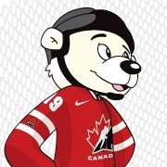The player | scores | a goal.
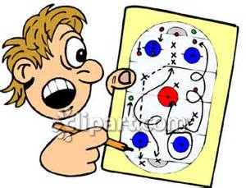  The coach | shows | a play.
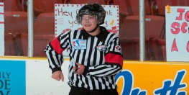  The referee | drops | a puck.
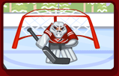  The goalie | stops | a shot.
The fan | cheers | a team.

The pl_y_r | _______s | a goal.
The c_ _ch | _______s | a play.
The r_f_r_ _ | _______s | a puck.
The g_ _l_ _ | _______s | a shot.
The fan | _______s | a team.

