Subject: | Social Studies
Title: | Puckster Travels Across Canada
Grade Level: | 5
Purpose: | Students label features on a map of Canada, and show Puckster’s travels across Canada, to broaden their understanding of the vastness of our country.
Curricular  Connections: | - Examine, critically, the physical geography of Canada by exploring the following questions and issues: What are the provinces and territories, capital cities, and bodies of water in Canada?  - Appreciate the geographic vastness of Canada.
Materials: | - Access to map of Canada  - Blank Map of Canada - attached  - Pencils, erasers, pencil crayons, ruler
Activity: | - Explain to the class that Puckster is making two trips across Canada to visit the capital cities in each province. He is flying by plane.  - His first trip is across the territories of Northern Canada.  - His second trip is from B.C. to Quebec, down through New Brunswick, and up to Newfoundland. He stops in each province’s capital city.  - Distribute Map of Canada.  - Students label: the major bodies of water surrounding Canada (Pacific, Arctic, & Atlantic oceans; Beaufort & Labrador Seas, Hudson & Baffin Bays, Davis Strait, Great Lakes, St. Lawrence River,) the provinces, the territories, and the capital cities.  - Puckster’s First Trip: Starting in the capital of Yukon Territory (Whitehorse) draw a straight line to the capital cities ending in Nunavut Territory (Iqaluit). Choose a colour for this line.  - Puckster’s Second Trip: Starting in the capital of B.C. (Victoria) draw a straight line to each of the capital cities from coast to coast. The end point is the capital city of Newfoundland (St.John’s). *Be specific about the order of the Atlantic Provinces. Choose a different colour for this line.  - Complete map by:  - colouring each of the provinces and territories a different colour.  - colouring the bodies of water.  - creating a legend for Puckster’s 2 travel routes, and the features labeled on the map (bodies of water, capital cities, travel route #1, travel route #2).
Extension: | - Name a Team Canada player from each of 5 different provinces. Locate the city they came from.  - Math extensions: calculate the distance between each of the capital cities using the web to determine distances. Calculate the total distance Puckster travelled on his two trips across Canada. How far is it as a return trip?
Assessment: | Students submit their map with:  - 10 provinces, 3 territories, 13 capital cities, and 10 major bodies of water clearly labeled.  - Puckster’s travel route drawn with straight lines between capital cities.  - A legend of the features on the map.  Mark for accuracy and neatness: labeling and colouring

Name: ______________
Puckster Travels Across Canada

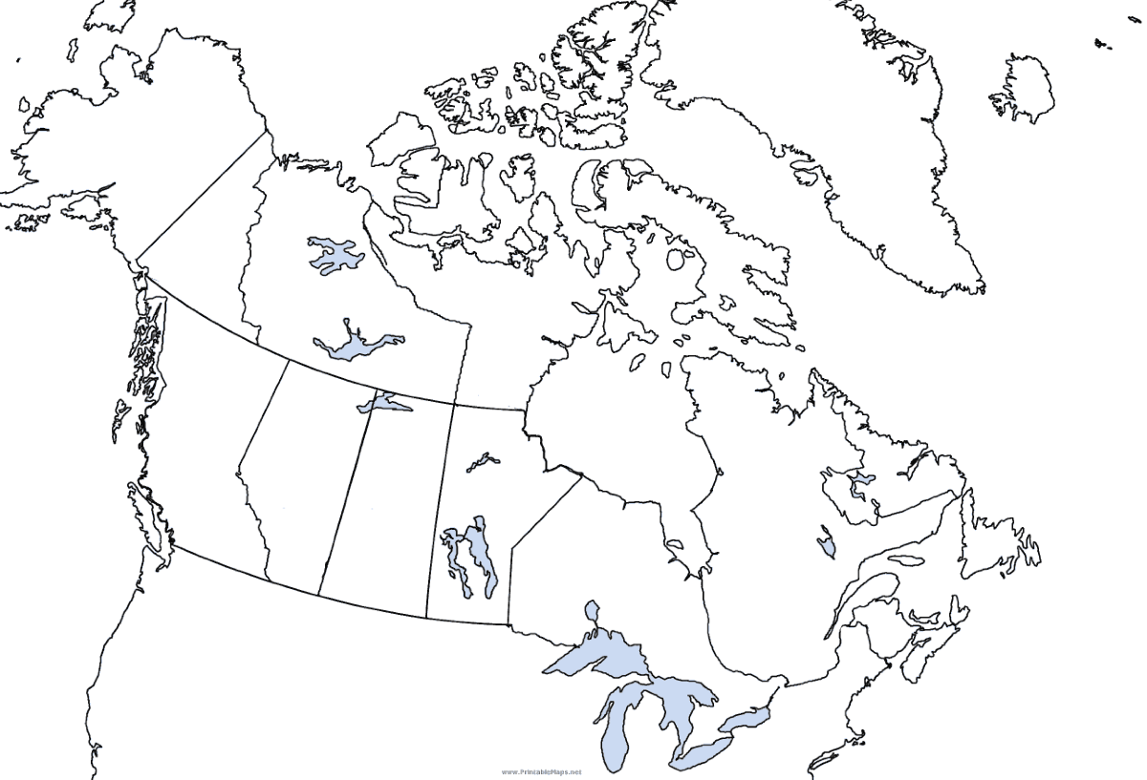
Legend:

