Subject: | Social Studies
Title: | Being Active
Grade Level: | K
Purpose: | Students will:  - examine how they are active  - discuss safe places to be active  - discuss safety in hockey
Curricular  Connections: | - Active Living in the Community  - describe appropriate places for children to play  - make choices to be active
Materials: | - chart paper or board to brainstorm vocabulary  - lift a flap hand out  - scissors & stapler
Activity: | - Intoduce hockey theme through story, song, poem or picture  - Teacher asks students:  - who is active, and where they go for physical activity  - who needs to know safety, and the rules, to keep players safe in a hockey arena  - what it means to respect every individual in their community  - Distribute lift a flap worksheets.  - Students identify symbols or pictures they recognize.  - Teacher reads the sentence and demonstrates how to make the booklet.  - Students cut along the cutting lines, taking care not to cut through the top of each flap.  - Teacher staples the books along the top.  - Students make, and read, real or silly sentences by lifting the flaps in various sequences.  - Teacher may make a large book and laminate it for the class to use throughout the school year.
Extension: | - Students share their sentences with classmates.  - Students make up a sentence and have their partner move their pages to corresponding sentences.
Assessment: | - Does the student: make their booklet independently?  - identify symbols and pictures in the booklet?  - read sentences aloud?

The player | 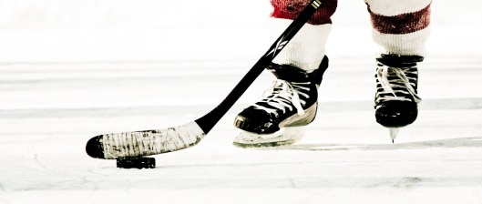  shoots | 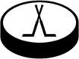  a puck.
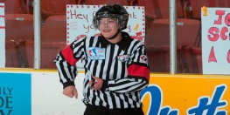  The referee | 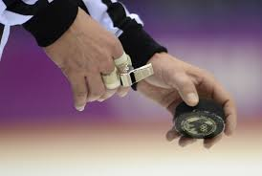  drops | a puck.
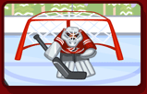  The goalie | 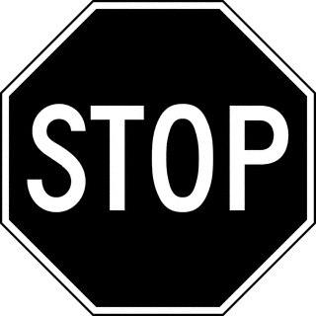  stops | a puck.

